Accident (Near Miss) Investigation Report

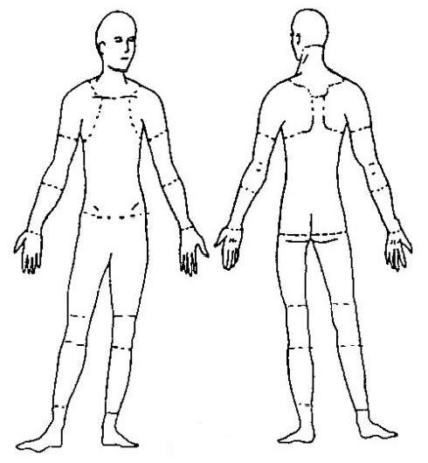
Instructions: Complete this form as soon as possible after an incident that results in serious injury or illness. (Optional: Use to investigate a minor injury or near miss that could have resulted in a serious injury or illness.)

This is a report of a:  Death  Lost Time  |  | Dr. Visit Only | - First Aid Only  Near Miss
Date of incident: | This report is made by: | - Employee | - Supervisor | - Team | - Final Report

Step 1: Injured employee (complete this part for each injured employee)
Name: | Sex:  Male  Female |  | Age:
Department: | Job title at time of incident:
Part of body affected: (shade all that apply) | Nature of injury: (most serious one)  - Abrasion, scrapes  - Amputation  - Broken bone  - Bruise  - Burn (heat)  - Burn (chemical)  - Concussion (to the head)  - Crushing Injury  - Cut, laceration, puncture  - Hernia  - Illness  - Sprain, strain  - Damage to a body system:  - Other | This employee works:  - Regular full time  - Regular part time  - Seasonal  - Temporary
 |  | Months with this employer
 |  | Months doing this job:
 |  | (e.g.: nervous, respiratory, or circulatory systems)

Step 2: Describe the incident
Exact location of the incident: | Exact time:
What part of employee’s workday?  Entering or leaving work  Doing normal work activities
- During meal period  During break  Working overtime  Other
Names of witnesses (if any):

Number of attachments: | Written witness statements: | Photographs: | Maps / drawings:
What personal protective equipment was being used (if any)?
Describe, step-by-step the events that led up to the injury. Include names of any machines, parts, objects, tools, materials and other important details.

Description continued on attached sheets: 

Step 3: Why did the incident happen?
Unsafe workplace conditions: (Check all that apply)  - Inadequate guard  - Unguarded hazard  - Safety device is defective  - Tool or equipment defective  - Workstation layout is hazardous  - Unsafe lighting  - Unsafe ventilation  - Lack of needed personal protective equipment  - Lack of appropriate equipment / tools  - Unsafe clothing  - No training or insufficient training  - Other: | Unsafe acts by people: (Check all that apply)  - Operating without permission  - Operating at unsafe speed  - Servicing equipment that has power to it  - Making a safety device inoperative  - Using defective equipment  - Using equipment in an unapproved way  - Unsafe lifting by hand  - Taking an unsafe position or posture  - Distraction, teasing, horseplay  - Failure to wear personal protective equipment  - Failure to use the available equipment / tools  - Other:
Why did the unsafe conditions exist?
Why did the unsafe acts occur?
Is there a reward (such as “the job can be done more quickly”, or “the product is less likely to be damaged”) that may have encouraged the unsafe conditions or acts?  Yes  No
If yes, describe:
Were the unsafe acts or conditions reported prior to the incident?  Yes  No
Have there been similar incidents or near misses prior to this one?  Yes  No

Step 4: How can future incidents be prevented?
What changes do you suggest to prevent this injury/near miss from happening again?

- Stop this activity  Guard the hazard  Train the employee(s)  Train the supervisor(s)

- Redesign task steps  Redesign work station  Write a new policy/rule  Enforce existing policy

- Routinely inspect for the hazard  Personal Protective Equipment  Other:
What should be (or has been) done to carry out the suggestion(s) checked above?

Description continued on attached sheets: 

Step 5: Who completed and reviewed this form? (Please Print)
Written by:  Department: | Title: Date:
Names of investigation team members:
Reviewed by: | Title:  Date:

